Commercial offer
Dear Sirs and Madams,

Let me introduce myself, my name is Marat Terentev. I’m a Head of timber products sales. We do business in Russia, Udmurt Republic. Our company “Uvadrev-holding LLC” is considered to be one of the largest wood-harvesting and wood-processing enterprises in the field of the timber industry in West Ural region of Russia. We have our own raw material base that counts around 550 000 cubic meters.

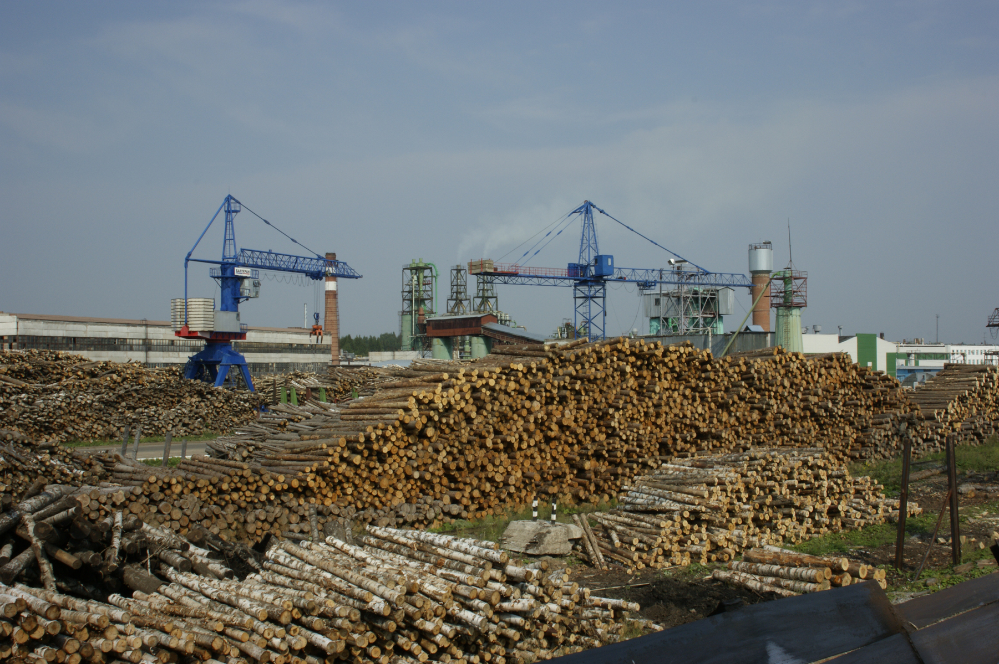
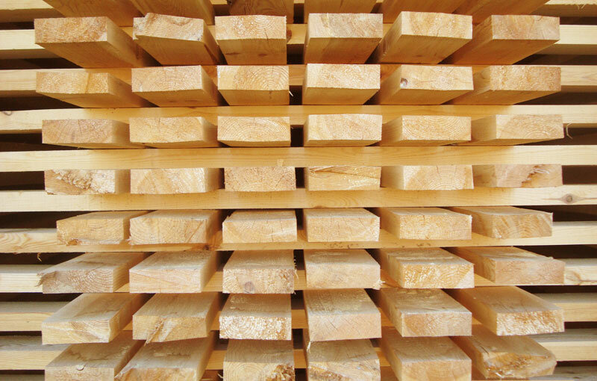

We offer you a delivery of coniferous and deciduous lumber (spruce, pine, aspen and birch).
Our company has well-developed logistics infrastructure: we have own railway dead-ends and trucks, be sure that we will deliver the goods to you on time.

Our equipment: milling-circular saw line, consisting of machines of the German company EWD, that allows us to produce high quality lumber. The line includes: milling machine, circular saw, edge cutting line, multi-saw machine. After sorting lumber enters the drying chamber of periodic action that was produced by the Latvian company "BaltBrand", it’s total volume of a single load is 420 cubic meters.

Production of timber is carried out in quantity and size of the customer.
Lumber thickness from 17 mm.
Width of timber from 60 mm.
Length of timber from 2,0 to 6,1 m.
Performance 25 000 – 30 000 m3 of lumber per year (possible increase in volumes).

At the moment, our company has passed the audit procedure and received the FSC certificate.

Please provide specifications for hardwood and softwood lumber by e-mail, or contact the sales Department by phone.

We will be high appreciated to get your soon answer and start cooperation with you!
Yours faithfully, Head of timber products sales,
Marat Terentev
Russia, 427261 the Udmurt Republic, UVA, street Zavodskaya,1
Forest products sales Department: (3412) 27-15-23 EXT. 57-45
8-912-020-58-85. E-mail: tms@hk-vostok.ru, pks@uvadrev.ru
www.uvadrev.ru

