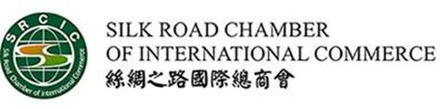
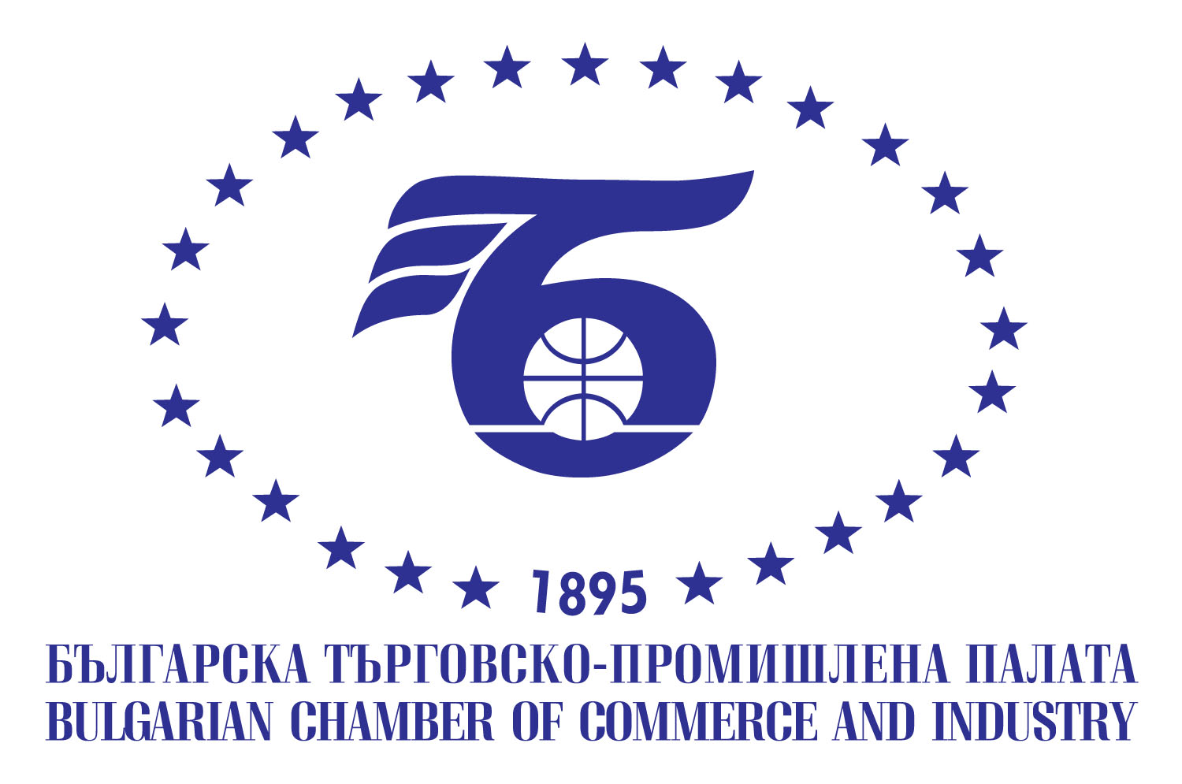

The Belt and Road in Bulgaria
20 November 2018

Sofia, 9 Iskar Str
BCCI, fl. 1, Hall A

DRAFT PROGRAMME
14.30 – 15.00 | REGISTRATION
15.00 – 15.30 | OFFICIAL OPENING  Mr. Tsvetan Simeonov, President of the Bulgarian Chamber of Commerce and Industry  Mr. Alexander Tomov, Former deputy prime – minister of Bulgaria
H.E. Mr. Zhang Haizhou, Ambassador Extraordinary and Plenipotentiary of the People's Republic of China to Bulgaria
Mr. Li Zhonghang, Vice Chairman and Secretary General of Silk Road Chamber of International Commerce

16.00 – 16.30 | SRCIC PRESENTATION and its INITIATIVES  Video introduction  “Build the cooperation platform for Bulgaria in the Belt and Road  Mr. Jean-Guy Carrier, Executive Chairman of Silk Road Chamber of International Commerce, introducing Silk Road Urban Alliance, Silk Road Enterprise Development Alliance as well as Artwork International Trading Center.  Presentation by David Kiang, Chairman of Silk Road International Development Fund
16.30 – 17.00  17.00– 17.10 | Panel discussion: Trade, Investment and business China Bulgaria cooperation  Chair: Mr. Jean-Guy Carrier, Executive Chairman of Silk Road Chamber of International Commerce  SRCIC flag handover to its member BCCI.

Working language: English

