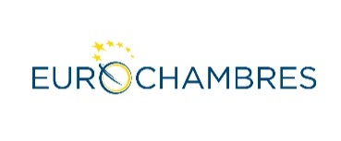

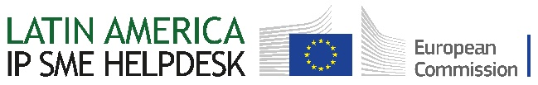

**ONLINE MEETING**

**BULGARIA – ARGENTINA: POSSIBILITIES FOR BUSINESS COOPERATION**

7th February 2023, 15.00h. EET

[Zoom Registration](https://us06web.zoom.us/meeting/register/tZItduitrDMtGNIrUlrHFZynPcWcgi6vWdjV)

**DRAFT - PROGRAMME**

|  |  |
| --- | --- |
| **15.00 – 15.10**  **15.10 – 15.20**  **15.20 – 15.25**  **15.25 – 15.30** | ADDRESS by **Mr. Tsvetan Simeonov**  President of the Bulgarian Chamber of Commerce and Industry  ADDRESS by **Mr. Marcelo Elizondo**  Director of CAC and President of ICC Argentina  Special remarks by **H.E. Mr. Stoyan Mihaylov**, Ambassador Extraordinary and Plenipotentiary of Bulgaria to Argentina  Special remarks by **Mr. Daniel Horacio Cottini**, Chargé d’affaires at the Embassy of the Republic of Argentina in Sofia /tbc/ |
| **15.30 – 15.50**  **15.50 – 16.10** | PRESENTATION of the investment climate and business opportunities in Bulgaria,  Representative of **InvestBulgaria Agency**  PRESENTATION of the business climate in Argentina  **Mr. Matías Bolis Wilson**, CAC's Chief Economist |
| **16.10 – 16.55**  **16.55 – 17.10** | Intellectual Property Rights (IPRs) - an overview of how to acquire IPRs in Argentina  **Mrs. Gergana Dimitrova**, IP expert, Latin America IP SME Helpdesk  Q &A |

**17.10 – 17.30** One-to-one meetings with IP SMEs Helpdesk expert

**17.30** Closing remarks

*Working language: English*

### Privacy Statement

### The Latin America IP SME Helpdesk is very committed to protecting its users’ privacy and personal data. All data entered upon registration will be used only to provide you with the requested services and statistical purposes and is managed in conformity with Regulation (EC) No 2018/1725. The data will be processed by the coordinator of the Helpdesk - Universidad de Alicante - and the data controller is Head of Unit EISMEA I-02. SMP / COSME Pillar, representing the European Innovation Council and SMEs Executive Agency (EISMEA), which acts under the powers delegated by the European Commission. Should you have any queries on the processing of your personal data, please visit our full data privacy statement at

<https://intellectual-property-helpdesk.ec.europa.eu/ip-helpdesk-privacy-policy_en>