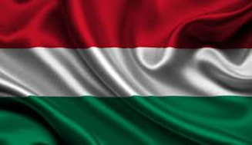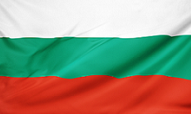

**Bulgarian-Hungarian Business Forum**

*Sofia, 29th May 2025*

**DRAFT PROGRAMME**

Language: English

Location: **Grand Hotel Sofia (1 General Gurko, Sofia), 2nd floor**

Moderator: **Dr. Rossen Tkatchenko**, President, Hungarian-Bulgarian Chamber of Commerce

|  |  |
| --- | --- |
| **29th May 2025 (Thursday)** | |
| 13:30 – 14:00 | Registration and coffee |
| **14:00 – 14:40** | **Official opening ceremony of the Business Forum** |
|  | Opening remarks of **H. E. Petar Dilov**, Minister of Economy and Industry of Bulgaria  Opening remarks of **H. E. Péter Szijjártó,** Minister of Foreign Affairs and Trade of Hungary  Welcoming remarks of **Mr. Tsvetan Simeonov**, President, Bulgarian Chamber of Commerce and Industry  Welcoming remarks by **Mr, Gabor Jenei**, President, Hungarian Export Promotion Agency |
| 14:40 – 15:20 | Presentations  Invest Bulgaria Agency  National Company Industrial Zones  Hungarian Export Promotion Agency |
| 15:20 – 15:30 | Coffee break |
| 15:30 – 17:30 | **B2B meetings** |