For more information |  | 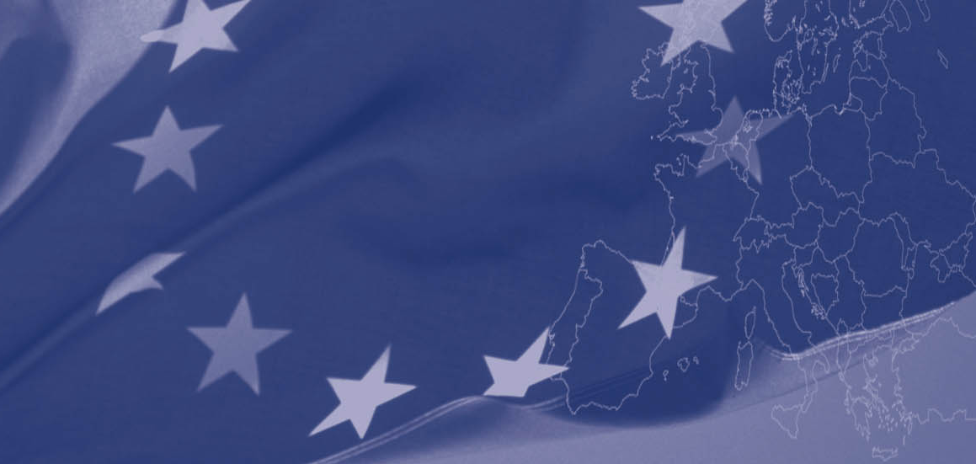
Eurasia-Fashion project  Dr. Takis Lybereas  Project Co-ordinator  Hellenic Clothing Industry Association  51 Ermou str., Athens  10563, Greece.  Tel. +30 210 3234811  Fax +30 210 3239159  Email: info@skee.gr  URL. www.eurasia-fashion.eu  Eurasia-Fashion Project Partners:  This programme is implemented by the Hellenic Clothing Industry Association. The views expressed in this publication do not necessarily reflect the views of the European Commission | “The European Union is made up of 27 Member States who have decided to gradually link together their know-how, resources and destinies. Together, during a period of enlargement of 50 years, they have built a zone of stability, democracy and sustainable development whilst maintaining cultural diversity, tolerance and individual freedoms.  The European Union is committed to sharing its achievements and its values with countries and peoples beyond its borders”.  The European Commission  is the EU’s executive body.  _________________________________________ | The European Union’s Central Asia Invest programme
  The Hellenic Clothing Industry Association | The International Apparel Federation | The Bulgarian Chamber of Commerce and Industry
  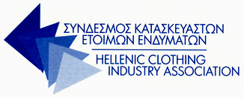 | 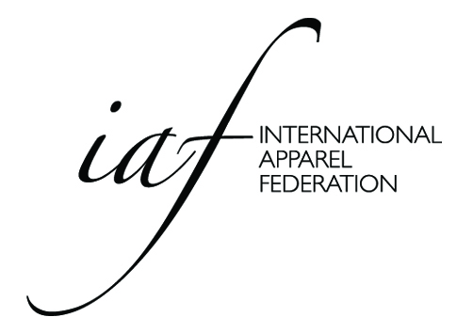 | 
  The Chamber of Commerce and Industry of Uzbekistan in Tashkent region | The Union of Textile Enterprises in Kyrgyzstan | The Association of Light Industry Enterprises in Kazakhstan
  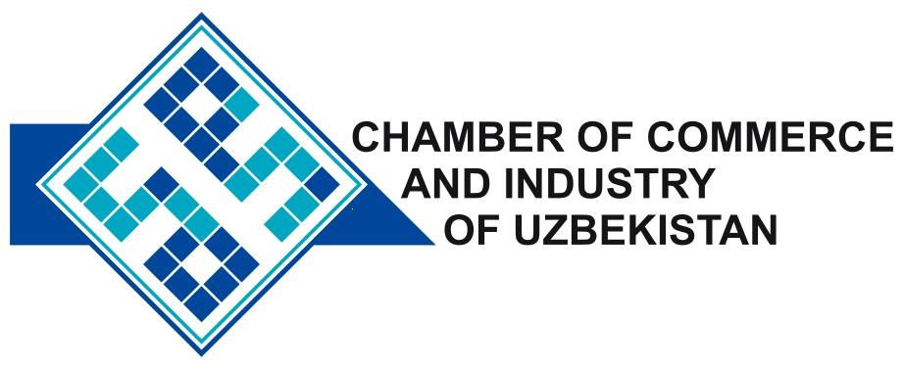 |   Association “Soyuztextile”
   | This project is funded by  The European Union
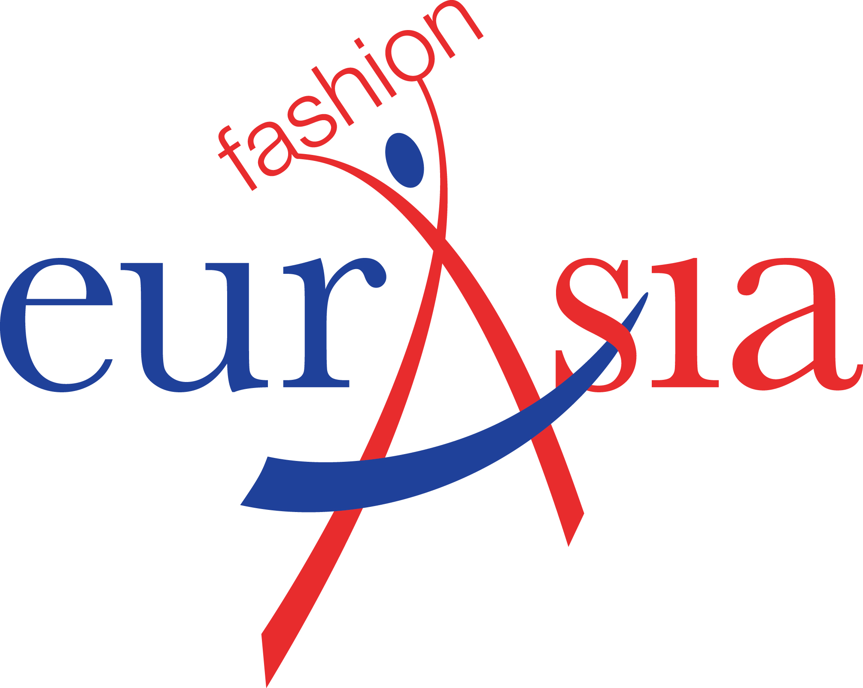

“Strengthening Central Asian - European partnership and co-operation in the fashion sector (EURASIA-FASHION)”

www.eurasia-fashion.eu

A project implemented by
The Hellenic Clothing Industry Association


This project is funded by
The European Union

The concept
The objectives
Programme Components
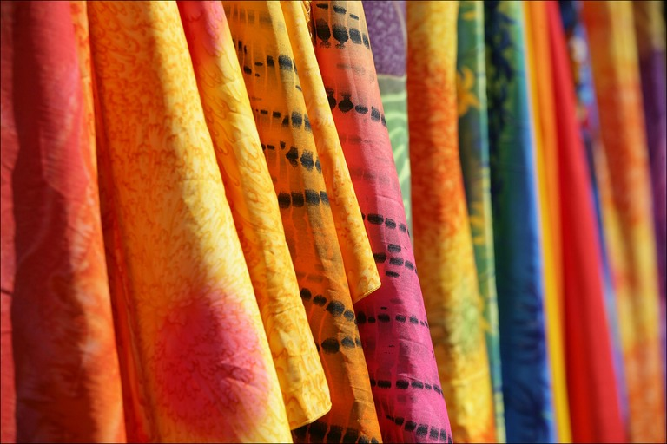
Strengthening Central Asian - European partnership and co-operation in the fashion sector (EURASIA-FASHION)
The ultimate scope of the Eurasia-Fashion project is to improve the internationalisation of the textile / clothing / fashion sector of the Central Asian countries and to develop specific mechanisms that will provide institutional capacity building to the targeted Business Intermediary Organisations (BIOs).

Kazakhstan, Kyrgyztan and Uzbekistan have shown a clear potential in the textile and clothing (T&C) sectors and targeted support could lead to economic growth. The T&C sectors in the countries concerned are characterised by a large concentration of raw materials and apparel subcontracting activities but economic, social and institutional barriers hold back export and internationalisation. The Eurasia-Fashion project will help the industry reach its full potential.

The project sets out to build the capacity of the BIOs to work more closely with SMEs and with the European actors to encourage new flows of investment. The final beneficiaries will be the SMEs in the T&C sector. To make sure all achievements are sustainable, the project will also focus on generating a stable ground for lobbying and advocacy functions.

The Main Goal is to promote the development of the private sector by encouraging the growth and expansion of Central Asian Small and Medium Enterprises in the fashion sector.
Key objectives are:
- to reinforce the role and the competences of Business Intermediary Organisations (BIO) in Kazakhstan, Kyrgyzstan and Uzbekistan, increasing their capacity to support SMEs and to influence policies in favour of micro and small scale companies.
- to establish permanent partnership channels to enable transfer of know-how and expertise exchange, as well as international business and commercial co-operation and diffusion of results,
- to upgrade the skills of BIO staff members making them better equipped to service the local SMEs, and
- to generate a stable ground for effective lobbying and advocacy functions in favour of micro and small scale companies.

Target groups
(a) the BIOs in the three target countries, namely Kazakhstan, Kyrgyzstan and Uzbekistan, and (b) the SMEs related to the Textile and Clothing (T&C) sectors in the three target countries
.

Component 1: Setting up the partnerships
- 1.1: Drawing up a Partnership Agreement.
- 1.2: Assessment of the BIOs’ capacity to influence policies in favour of SMEs in the target countries.
- 1.3: Establishing networking facilities.
Component 2: Institutional capacity building activities
- 2.1: Capacity building activities to the BIOs of the three target countries.
- 2.2: Selection of SMEs to be trained locally, based on specific criteria.
- 2.3: Organising collaborative workshops.
- 2.4: Delivery of training by the BIOs to the SMEs.
Component 3: Disseminating activities in favour of micro and small scale companies
- 3.1: Designing and Implementing an Action Plan for a Communication Strategy.
- 3.2: Development and distribution of international and analytical dissemination material.
- 3.3: Organisation of a brokerage event for the Textile/Clothing sector in Europe.
- 3.4: Monitoring and Follow up activities.

