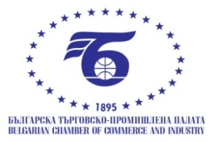
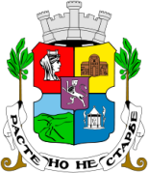
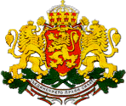

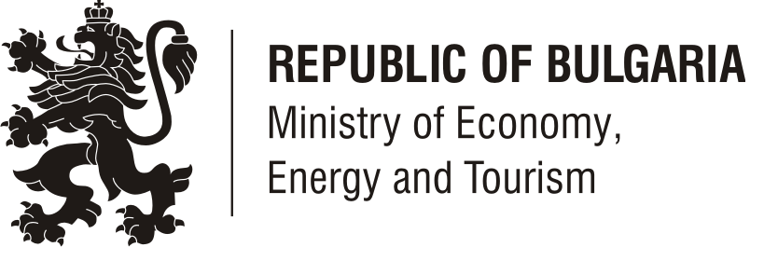

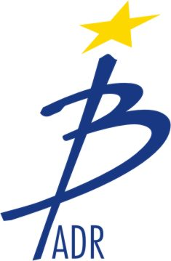

Посолство на Република България

в Букурещ

List of the Romanian business delegation accompanying, Mr Sоrin Oprescu, Mayor of Bucharest

As of 27.03.2013

 | Organization/  address | Participant | COMPANY’S BUSINESS ACTIVITIES | SPECIFIC INTERESTS
1 | UTI  Tel.: 0 733 888 486  E-mail: alina.oprisan@uti.eu.com  http://uti.eu.com | Mihai Gradinaru  Vicepresident UTI  ADRIAN FLOREA  Director General Business Unit ITS&Ticketing  DAN MIHAI TUDOR  Manager Dezvoltare Afaceri Business Unit ITS&Ticketing | UTI is a holding of powerful and flexible companies, capable of offering a wide and complex range of customized products and services.  By its five specialized business lines (Security Systems, Information Technology and Communications, Intelligent Transportation Solutions, Installations and General Contracting, Facility and Property Management), UTI provides turnkey solutions for transportation, energy, oil & gas industry, government, local authorities, financial institutions, corporations and commercial sites. | Companies and public authorities in the field:  - traffic management systems  - intelligent public transport systems including:  - automatic charging systems  -monitoring systems of public transport vehicles  - passenger information systems in vehicles and stations
2 | Maguay  E-mail: mihaela.iorgulescu@maguay.ro  Tel.: 0724.377.405  http://www.maguay.ro | Mihaela Iorgulescu | Manufacturer of computing systems: PCs, notebooks, servers and storage. Maguay developed its own line of servers (eXpertServer, PowerServer), storage systems (eXpertStor, PowerStor), desktop (OfficePower, GamePower, PowerStation ) and mobile (eXpertBook, MyWay) systems.  Integrator of complex IT systems  Software applications developer
3 | ALO ASIGURARI  E-mail: olgarece@gmail.com  Tel: 729035237  www.alo-asigurari.ro | Olga Rece | Romanian insurance broker which specializes in corporate insurance and also in damages surveys at the request of foreign insurance companies | We wish to meet and establish cooperation with Bulgarian insurance companies both in representation for damages surveys for events occurring in Romania and also in insurance brokerage, particularly for motor third party liability and casco.
4 | Astra Vagoane  Tel.: 0730 009 299  www.astra-passengers.ro | Scarlat Mihai  Negret Cornel  Marketing director | ASTRA produce the full range of passenger rail vehicles, among which first and second class coaches, restaurants, snack bars, sleeping cars, couchettes, power cars, luggage cars, EMU and DMU train, PUSH-PULL trains, trams, hospital trains, special trains for the Ministry of Defense, etc. | Management of the Railway Company in Bulgaria and the management of the local electric transport company (in charge of trams)
5 | ADION PRODIMPEXTRANS S.R.L  E-mail: cornel_cosareanu@yahoo.com  Tel.: 0722.228.533  http://www.adion.ro/ | Cosareanu Corneliu Petre  President | Direct importer of over 3000 products, as:  -medical equipment for diagnostic and treatment (oscilometers, sphygmomanometers, otoscopes & ophthalmoscopes, stethoscopes, ECG, EEG, audiometers, glucometers, osteosonographes, aerosols, ORL units, etc.);  -equipment for operation and intensive care rooms (operating tables and lights, surgical suction pumps, monitors and devices for anesthesia, sterilization, defibrillators, electro surgical units, etc.);  -medical furniture for hospitals, clinics and consulting rooms;  -equipment for intervention in emergency cases;  -surgical instruments and medical disposables
6 | ADREM  www.adrem.ro | Tiberiu Gegiu  Director dezvoltare, divizia servicii integrate  Sorin Ocos  Director vanzari, divizia scada& automatizari | We are a company that provides engineering services and solutions for problems related to energy and industrial applications.  Our mission is to be a customer oriented company and our priority is to satisfy the client’s needs.  Our goal is to increase the profitability and efficiency of our clients’ projects, making full use of the experience, dedication and training of our staff. | Interested in meeting: energy providers, partners for construction and electrical projects, producers of electric equipment, general contractors in projects of utility companies (electricity, water, gas, transport), automation market integrators
7 | Pontica(Elidor)  www.elidor.ro | SILVIA BOCAI  Project manager | ELIDOR Laboratories manufacture bout 400 kind of natural products for internal and external use such as suppliments (tablets and syrups) and dermoto-cosmetics products like as (gels, emulstions,ointentments, creams, shampoons). We developed our own methods based on natural products for treatment of different kind of diseases:  Chronic and degenerative rheumatism;Flu,fewer,cough and coryza; Secondary effects of menopause; Treatment of acute diarrhea syndrome; Increasing of body immunity and decreasing of body toxicity | Interested in distributors of medicines and parapharmaceuticals to become agents, representatives, distributors of this company on the Bulgarian market.
8 | FAST ECO SA  www.fasteco.ro | MARIN DANIEL | We focused on the development of the production of module substations for heating and hot tapped water, pumping groups, electric boards and automations and we have permanently in view a permanent growth and diversification of our business portfolio.Main businesses:  Rehabilitation and modernization of centralized heating systems. Designing, manufacturing, mounting and start-up of module substations for hot tapped water and heating using the primary thermal agent from the heating network. Service for heat exchangers.  Designing, production, revamping and maintenance of electrical installations and automations.  Design, manufacturing, calibration, installation, repairing and servicing of hot and cold water meters and thermal energy meters.  Metrological tests and service for measuring systems  Designing and construction of heat networks, sewage networks, water distribution networks.  Mechanical working; design and execution of metallic confections. | Interested in meeting companies in the fields of heating, plumbing, electrical, renewable energy.
9 | SALROM - Compania Nationala a Sarii  www.salrom.ro | Lucia Tanasa | extraction, management and commercialization of the salt and non – metalliferous substances (limestone, mica, graphite, feldspar and other)  promotion of the tourism for treatment and pleasure in the salt mines. | BORENI, CHIMSNAB-ORBEL; ET GEORGE SEMOV-Edit 5; MILADINOV Impex Ltd; MULTICOM; ORLICA; Et SIVES GROUP EOOD; Et Gh TOSAK KOSTUROV; Solaviki (VEN METAL CO); Astia; Et Margarita Naidenova; BSC-Kanotrans; Avex Doicev; Terra Technics; Atis Engineering Metalsystem

